Sam Tenney

Homework 3

1. Glyburide versus Insulin
2. *Homework 3;
3. 

On average, the percent fat mass of newborns whose mothers received glyburide is 12.80 (CI 95% 11.00 to 14.60) while the percent fat mass of newborns whose mothers received insulin is only 11.20 (CI 95% 9.87 to 12.53).

1. Notation:

Null Hypothesis: Ho

Alternative Hypothesis: Ha

Mean percent fat mass for glyburide: µg

Mean percent fat mass for insulin: µi

Hypotheses:

Ho: µg = µi or µg - µi = 0

Ha: µg ≠ µi or µg - µi ≠ 0

1. n1 = 41

n2 = 41

y1,4 = 16.60, the percent fat mass of the 4th newborn whose mother was treated with glyburide.

y2,10 = 10.45, the percent fat mass of the 10th newborn whose mother was treated with insulin.

1,4 = 16.60 – 12.80 = 3.80

2,10 = 10.45 – 11.20 = -0.75

e)

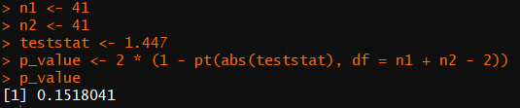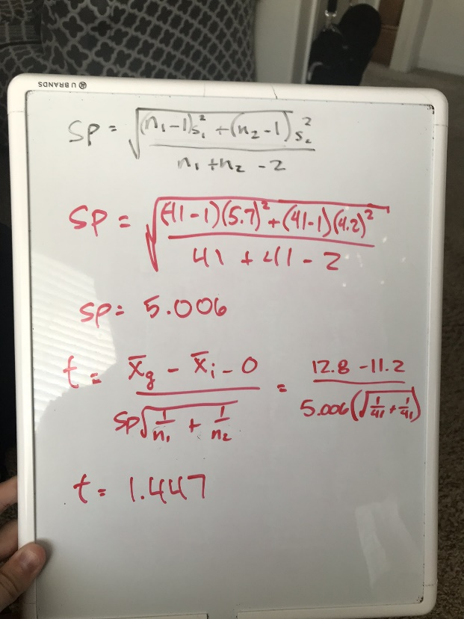



| Method | Variances | DF | Test Statistic | p-value |
| --- | --- | --- | --- | --- |
| Pooled | Equal | 80 | 1.45 | 0.1518 |
| Satterthwaite | Unequal | 73.555 | 1.45 | 0.1521 |



The test statistic (1.45) and p-value (0.1518) from the SAS program agree with the test statistic (1.447) and p-value (0.10 < p-value < 0.20) I calculated by hand in 1e. See pooled method in provided table, “Glyburide versus Insulin Two-Sample t-test Results” for SAS program results.

1. The p-value is between 0.10 and 0.20, which is greater than our threshold of 0.05. Thus, we fail to reject the null hypothesis and conclude that there isn’t enough evidence to suggest there is a difference between the mean percent fat mass of newborns whose mothers were treated with glyburide or insulin.
2. 

| Treatment | Mean | Upper Bound | | Lower Bound | Std Dev |
| --- | --- | --- | --- | --- | --- |
| glyburide | 12.8 | 11.0 | 14.5 | | 5.7 |
| insulin | 11.2 | 9.8 | 12.5 | | 4.2 |
| Diff in means | 1.6 | -0.6 | 3.8 | | 5.0 |

On average, the difference in percent fat mass between newborns whose mothers were treated with glyburide and newborns whose mothers were treated with insulin is 1.6 (CI 95% -0.6 and 3.8). The confidence interval includes 0, so the interval confirms what we observed in our t-test (Ho: µg = µi or µg - µi = 0).

1. We wanted to find if there was a difference in percent fat mass in neonates of women with gestational diabetes treated with glyburide or insulin. We found that on average, the percent fat mass of newborns whose mothers received glyburide is 12.8 (CI 95% 11.0 to 14.6) while the percent fat mass of newborns whose mothers received insulin is only 11.20 (CI 95% 9.87 to 12.53). To test if these results were significant, we performed a two-sample t-test to find the probability of getting the results we observed. We assumed that there was no difference between the two treatments and tested to see if there was a difference in mean percent fat mass of neonates. We found the p-value to be between 0.10 and 0.20, which is greater than our threshold of 0.05. Thus, we fail to reject the null hypothesis and conclude that there isn’t enough evidence to suggest there is a difference between the mean percent fat mass of newborns whose mothers were treated with glyburide or insulin. On average, the difference in percent fat mass between newborns whose mothers were treated with glyburide and newborns whose mothers were treated with insulin is 1.6 (CI 95% -0.6 and 3.8). The confidence interval includes 0, so the interval confirms what we observed in our t-test (Ho: µg = µi or µg - µi = 0).
2. The Art of Oreo Dunking
3. # Homework 3
4. 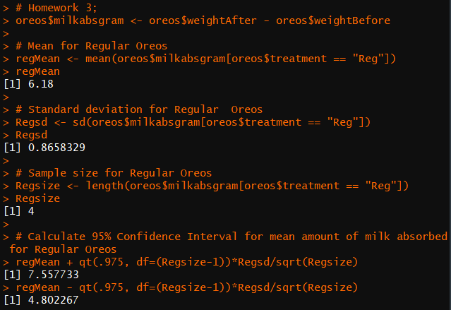

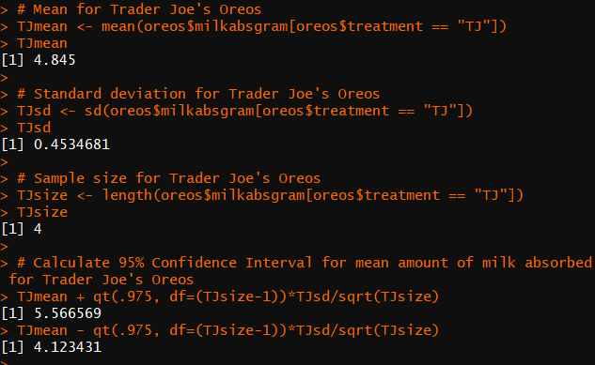

On average, Regular Oreos absorbed 6.18 grams of milk in 10 seconds (95% CI 4.80g to 7.56g) while Trader Joe’s Joe-Joe’s absorbed only 4.84 grams of milk (95% CI 4.12g to 5.57g).

1. Mean amount of milk absorbed in 10 seconds by Regular Oreos = µreg

Mean amount of milk absorbed in 10 seconds by Trader Joe’s Joe-Joe’s = µtj

Null Hypothesis (Ho): µreg = µtj or µreg - µtj = 0

Alternative Hypothesis (Ha): µreg ≠ µtj or µreg - µtj ≠ 0

1. n1 = 4

n2 = 4

y1,4 = 5.49g, the amount of milk absorbed for the fourth Regular Oreo

y2,3 = 4.57g, the amount of milk absorbed for the third Trader Joe’s Joe-Joe

1,4 = 5.49 - 6.18 = -0.69

2,3 = 4.57 – 4.845 = -0.275

1. 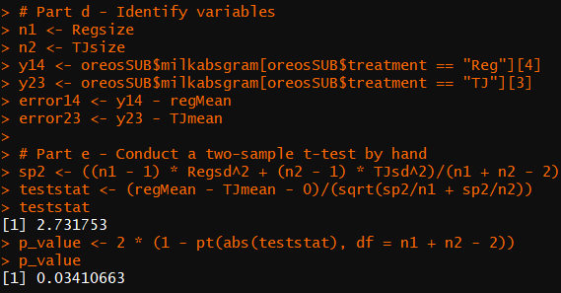

test statistic = 2.73

p-value = 0.034

1. t-test results from R:

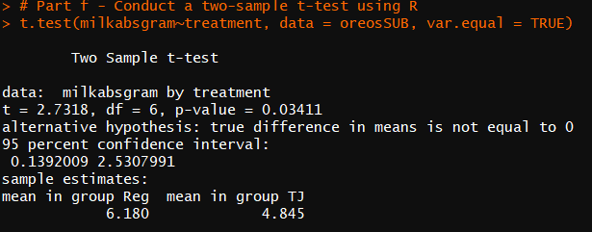

The results from my hand calculated t-test and the ones from R are the same.

1. The p-value is small enough to reject the null hypothesis and conclude that the mean amount of milk absorbed by Regular Oreos and Trader Joe’s Joe-Joe’s are not equal.
2. On average, the difference in mean amount of milk absorbed in 10 seconds for Regular Oreos and Trader Joe’s Joe-Joe’s is 1.335g (CI 95% 0.14 to 2.53).
3. We wanted to find out if the type of cookie (Regular Oreos, Trader Joe’s Joe-Joe’s) affected how much milk was absorbed (in grams) by the cookie when dipped in 2% milk for 10 seconds. We found that on average, Regular Oreos absorbed 6.18 grams of milk in 10 seconds (95% CI 4.80g to 7.56g) while Trader Joe’s Joe-Joe’s absorbed only 4.84 grams of milk (95% CI 4.12g to 5.57g). To test if these results were statistically significant, we performed a two-sample t-test on the average differences of milk absorbed. We assumed the average amount of milk absorbed for Regular Oreos and Trader Joe’s Joe-Joe’s are equal. Our calculated p-value (0.034) was small enough to reject our null hypothesis that the mean amount of milk absorbed in grams by Regular Oreos and Trader Joe’s Joe-Joe’s after being dipped in milk for 10 seconds are equal and conclude that the average amounts of milk absorbed between the two cookie types are not equal. On average, the difference in the mean amount of milk absorbed is 1.335g (CI 95% 0.14 to 2.53).